SJRC S70W GPS Quadcopter Introduction

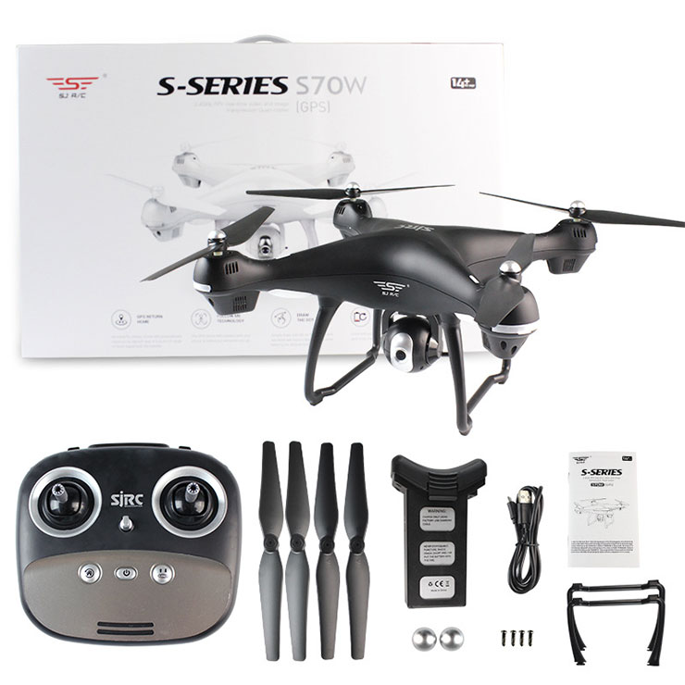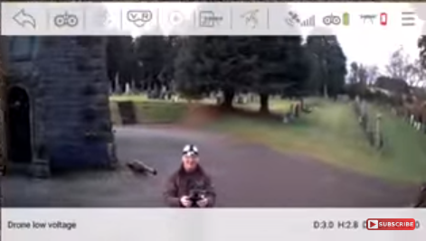

**DEMO OUTLINE**

1. **What is the benefit of GPS?**
2. **Description of Remote Controller Features**
3. **Video of Remote Controller Operation**
4. **Pictures from Drone** [**Still Photos from Jim's Drone**](https://photos.google.com/album/AF1QipOdLznL6ge64tX4NjXc12N3icpS-DBvk_TBjyqn)
5. **Video from Jim’s Drone** [**Video from Drone**](https://drive.google.com/file/d/1k-8eGrwH129XiRB0OxCEOf4Q4QilGs4M/view?usp=sharing)

**I. What is significance of GPS mode???**

**II. Description of Remote Controller Features**

**Pairing** 12 then 6 on left control

Connect WiFi - To Connection offered by drone “SJ-XXXXXX”

**Gyroscope Calibration** 11 and 1

**GPS Calibration**  1 and 11

Pick Drone Up and Rotate 360

Point Front of Drone toward ground and Rotate 360

**Take Off and Landing Button** (with auto hover)

Depress for 3 seconds for e stop

**Left Joy Stick** UP/DOWN for UP/DOWN

LEFT/RIGHT to ROTATE Drone Left or Right

**Right Joy Stick** Forward/Reverse

Left/Right Fly to Left. Fly to Right

**Return Home Button** Return Home

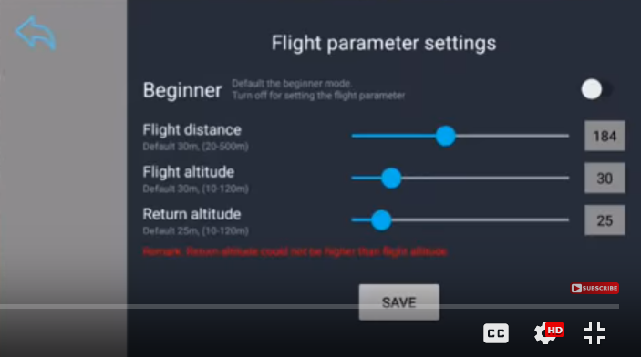

**Follow Me Button** Follows Cell Phone

Short Press second time to cancel

Long Press to enter Trim Mode

**Headless Mode Button** Long Press to exit GPS Mode

When you active **headless mode**, the onboard flight computer always aligns the drone movements to be relative to the controller. So it does not matter which way the drone forward direction is pointing. When you push forward, the drone moves forward relative to your direction, not the heading of the drone.

**Rudder/Camera Angle Adjustment** 0-90 degrees

**Photo Button** Save Photo to micro/sd card AND on the cell phone

**Video Button** Creates Video on micro/sd card AND on the cell phone

III. [Basic Operation Video](https://www.youtube.com/watch?v=cbLN2ORGT18)